**Exercise 4: Creating and Configuring a Maven Project**

**Scenario:**

You need to set up a new Maven project for the library management application and add Spring dependencies.

**Steps:**

1. **Create a New Maven Project:**
   * Create a new Maven project named **LibraryManagement**.
2. **Add Spring Dependencies in pom.xml:**
   * Include dependencies for Spring Context, Spring AOP, and Spring WebMVC.
3. **Configure Maven Plugins:**
   * Configure the Maven Compiler Plugin for Java version 1.8 in the pom.xml file.

**Code:**

*Main.java -*

package com.library;

import org.springframework.context.ApplicationContext;

import org.springframework.context.support.ClassPathXmlApplicationContext;

import com.library.service.BookService;

public class MainApp {

public static void main(String[] args) {

// Load Spring context

ApplicationContext context = new ClassPathXmlApplicationContext("applicationContext.xml");

// Get BookService bean

BookService bookService = context.getBean("bookService", BookService.class);

// Test

bookService.addBook("Hell's Paradise");

}

}

*BookService.java –*

package com.library.service;

import com.library.repository.BookRepository;

public class BookService {

private BookRepository bookRepository;

// Setter for dependency injection

public void setBookRepository(BookRepository bookRepository) {

this.bookRepository = bookRepository;

}

public void addBook(String bookName) {

System.***out***.println("Adding book: " + bookName);

bookRepository.saveBook(bookName);

}

}

*BookRepository.java –*

package com.library.repository;

public class BookRepository {

public void saveBook(String bookName) {

System.***out***.println("Book saved: " + bookName);

}

}

*applicationContext.xml –*

<?**xml** version=*"1.0"* encoding=*"UTF-8"*?>

<**beans** xmlns=*"http://www.springframework.org/schema/beans"*

xmlns:xsi=*"http://www.w3.org/2001/XMLSchema-instance"*

xsi:schemaLocation=*"*

*http://www.springframework.org/schema/beans*

*http://www.springframework.org/schema/beans/spring-beans.xsd"*>

<!-- Define Repository Bean -->

<**bean** id=*"bookRepository"* class=*"com.library.repository.BookRepository"*/>

<!-- Define Service Bean with Dependency Injection -->

<**bean** id=*"bookService"* class=*"com.library.service.BookService"*>

<**property** name=*"bookRepository"* ref=*"bookRepository"*/>

</**bean**>

</**beans**>

*Pom.xml –*

<project xmlns="http://maven.apache.org/POM/4.0.0"

xmlns:xsi="http://www.w3.org/2001/XMLSchema-instance"

xsi:schemaLocation="http://maven.apache.org/POM/4.0.0

https://maven.apache.org/xsd/maven-4.0.0.xsd">

<modelVersion>4.0.0</modelVersion>

<groupId>com.library</groupId>

<artifactId>LibraryManagement</artifactId>

<version>0.0.1-SNAPSHOT</version>

<properties>

<java.version>1.8</java.version>

<spring.version>5.3.33</spring.version>

</properties>

<dependencies>

<!-- Spring Context -->

<dependency>

<groupId>org.springframework</groupId>

<artifactId>spring-context</artifactId>

<version>${spring.version}</version>

</dependency>

<!-- Spring AOP -->

<dependency>

<groupId>org.springframework</groupId>

<artifactId>spring-aop</artifactId>

<version>${spring.version}</version>

</dependency>

<!-- Spring WebMVC -->

<dependency>

<groupId>org.springframework</groupId>

<artifactId>spring-webmvc</artifactId>

<version>${spring.version}</version>

</dependency>

<!-- Servlet API (required for Spring WebMVC) -->

<dependency>

<groupId>javax.servlet</groupId>

<artifactId>javax.servlet-api</artifactId>

<version>4.0.1</version>

<scope>provided</scope>

</dependency>

</dependencies>

<build>

<plugins>

<!-- Maven Compiler Plugin -->

<plugin>

<groupId>org.apache.maven.plugins</groupId>

<artifactId>maven-compiler-plugin</artifactId>

<version>3.10.1</version>

<configuration>

<source>${java.version}</source>

<target>${java.version}</target>

</configuration>

</plugin>

</plugins>

</build>

</project>

**Output: (Screenshots)**

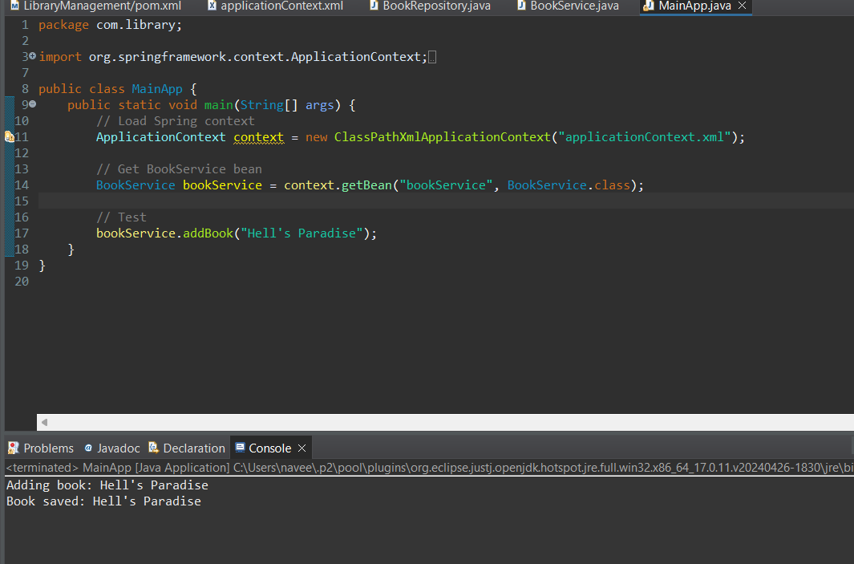

**Configured pom.xml –**

